 |  |  |  | 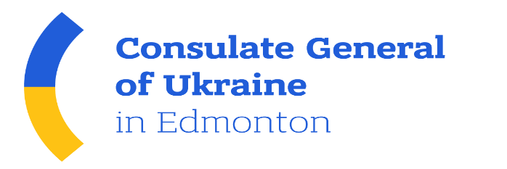
ONLINE Business Conference
PROSPECTS FOR COOPERATION: UKRAINE - CANADA
November 10, 2020 (18.00 Kyiv, 9 a.m. Edmonton)
Venue: Ukrainian CCI (Kyiv, 33, Velyka Zhytomyrska St., ZOOM Application)
Working languages: English/Ukrainian (with translation)

 |  | Moderator: Mr. Valeriy KOROL, Vice President of the UCCI
18:00 |  | WELCOMING REMARKS
 |  | Mr. Gennadiy Chyzhykov | President of the Ukrainian CCI
 |  | Mr. Dmytro Senik | Deputy Minister for Foreign Affairs of Ukraine
 |  | Mr. Andriy Shevchenko | Ambassador of Ukraine in Canada
 |  | Ms. Larisa Galadza | Ambassador of Canada to Ukraine
 |  | Mrs. Jackie Armstrong-Homeniuk | Member of the Legislative Assembly (parliament) of Alberta, Head of the Advisory Council on Alberta Ukraine Relations
 |  | Mr. Oleksandr Danyleiko | Consul General of Ukraine in Edmonton
18:25 |  | FTA - OPPORTUNITIES AND CHALLENGES IN MODERN CONDITIONS
 |  | Mr. Taras Kachka (tbc) | Deputy Minister for Development of Economy, Trade and Agriculture of Ukraine - Trade Representative of Ukraine
 |  | Mr. Vitaliy Milentiev | Representative of the UCCI in Alberta - President of the Alberta Ukraine Chamber of Commerce
18:45 |  | SPECIFICS OF THE CANADIAN MARKET FOR UKRAINIAN EXPORTERS
 |  | Ms. Emma Turos | Executive Director of the Canadian-Ukrainian Chamber of Commerce
 |  | Ms. Mariya Guzman | Leading Expert, Trade Facilitation Office (TFO) Canada
19:00 |  | EXPORT AND INVESTMENT POTENTIAL OF UKRAINE
 |  | Mr. Dmytro Sennychenko | Head of the State Property Fund of Ukraine
 |  | Mr. Sergiy Tsivkach | Executive Director, UkraineInvest
19:15 |  | PRACTICAL ASPECTS  EXPORT OF UKRAINIAN PRODUCTS TO THE CANADIAN MARKET  Canadian businessmen who already have cooperation with Ukrainian partners will share practical experience and talk about possible problems, opportunities and challenges
 |  | Mr. Ivan Lypovyk  Mr. Myron Pyzyk | Permanent Window Solutions - importing Ukrainian construction materials to Canada  Principal – bringing Carpathian bees to Ca
 |  | Q&A session – Discussion
19.30 |  | Closing remarks: Oleksandr Danyleiko, Valeriy Korol

